Classroom management system

1. **Problem Definition –**

**Problem Statement:**

In IUT, we don’t have a single classroom assigned to a particular group of students. Each section has to participate in classes taken in different classrooms according to a given schedule. But the classes often get canceled and extra classes. Quizzes or discussion classes are often taken. These unscheduled classes do not follow the given schedule. When such a change occurs, it’s difficult to manage a classroom for the particular group of students. Usually the floor staff has records of the booking time of classrooms and the whole procedure is done manually. He has to go through all the records to search a room. On the other hand, when a class is cancelled the floor staff isn’t usually informed. It gets more difficult when classrooms from different floors or buildings are booked. Sometimes, the same class get booked by two groups of students and they have to wait in front of that particular classroom. The unscheduled classes often get delayed or cancelled because of that. The teachers also have certain criteria for the rooms, for example – having a projector or being air-conditioned. These criteria are hardly met in the current system.

**Solution Statement:**

Our solution is a **real-time cloud-based Management Information System** for the classrooms in IUT which can manage as well as schedule all the classes and classrooms appropriately even when unscheduled events take place, by being accessible to a wide range of users at all times.

1. **Issues:**

* **Booking Conflicts:** The current system cannot show us the availability of classroom in real time. So, there is a possibility of the same class getting booked by two or more groups. As a result, students have to wait in front of the classes while the CRs and staff consult regarding the problem.

*Weight – 10*

* **Manual Errors:** A manual system is prone to manual errors. Manual errors can cause a variety of problems including booking conflicts, unavailability of classrooms, obtaining misinformation and so on.

*Weight – 10*

* **Inflexible:** The current system wasn’t designed to face problems like unscheduled quizzes and classes. So, whenever such an event occurs, the current system can’t provide us the desired classroom.

*Weight – 8*

* **Not meeting requirements:** The requirements of a teacher – projectors, air-conditioned, seat capacity, number of boards and so on, aren’t always ensured by the current system.

*Weight – 7*

* **Wastage of Resources:** Classrooms are the resources of an institution and these resources wasted due to the current system. When a class is cancelled then the system isn’t aware of the availability of that classroom. So, at a particular time we can have a lot of free classrooms but the people aren’t aware of it.

*Weight – 6*

* **Wastage of Manpower:** A floor staff has to be allocated to each floor in the current system.

*Weight – 6*

* **Time consuming:** It takes a lot of time to find available rooms and book them in the current system. Booking conflicts can also result in wasting the time of one or more groups.

*Weight – 5*

1. **Objectives:**

* The main problem of the current system is that it’s a manual system and changes to this manual system doesn’t reach every user of the system. To tackle this problem we are planning to develop a management information system which can handle all these manual tasks by letting us book classrooms. This is a less time-consuming and error-free process.
* The other part of our main problem is that the information is relayed to users easily. This is why out management information system needs to have great availability. So, we are planning to develop a website which would let us access this management information system from every platform. The website is hosted
* Our project will also have features to find classrooms based on requirements and easily show it our users.
* Any changes done to our new system is updated in the real-time cloud database. So, the availability of classroom in real-time is shown and no resource is wasted
* Manpower can be reduced by this system
* The classrooms can be access and book instantly by our proposed system
* Our project will also provide options to show the criteria of a classroom which includes – seat capacity, air-conditioning, number of boards, projector availability and so on. Users can see these requirements before booking the classroom.
* The project will also grants users to access and modify their previous records and can make scheduled booking as well
* Access control to different categories of users for security

1. **Requirements:**

For our project we would need a real-time cloud-database that can be available throughout the day and a computer program which will interact with the database and show the data to the end-users in a meaningful way. To ensure availability across all platforms we are planning to make the system accessible using a website. We are also planning to use a graphical user interface for the ease of access of the end-users.

1. **Constraints:**

* The project targets all the people of the institution which includes – teachers, students, staff and administration.
* The project is limited to online users only. Users must have access to the internet when needed.
* For the time being, our program is only targeting the users of IUT but we are planning to make a system like this available for any institution based on their requirements.

1. **Feasibility analysis**

**Technical:**

We will be using a number of markup languages as well as a number of Google services to accomplish our goals:

* HTML for the basic structure of our website
* CSS for formatting, layout and presentation
* JavaScript for adding and maintaining interactive elements and functions
* Firebase, a NoSQL database designed by Google
* FireHosting, a service provided by Google that easily lets us host a server and integrate the Firebase API into it for smooth operation

All of these technologies are easy to learn and use and hence, it would be technically feasible for us to learn and implement these in our project.

**Economical:**

For our project we are using a Firebase as the real-time cloud database. Firebase is free for small projects but it has some constraints. When our project can reach more people, we are planning to upgrade our current cloud-database plan to something larger, more reliable and more efficient. We would also need money to run the webserver for our system, if the number of users exceeds the bandwidth limit.

**Operational:**

The users or the owner of the system has to provide a monthly subscription fee for the project which shall be used to pay the cost for running online servers.

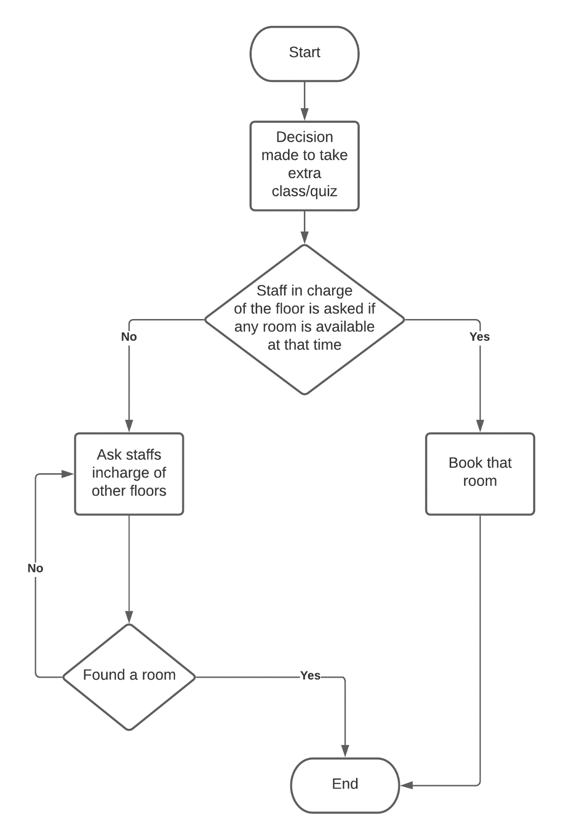**Flow Chart of Current System:**